Created By: Arulvel Rajan

**Topic**: Build Prompt AI and embed your custom AI within Power Apps

**Use Case:** RFP Content review and recommendations using AI Prompt & GPT

**Business Value:**

* Utilize Microsoft AI Hub & AI Prompt models to generate outputs that the business needs with accuracy, suggestions, and enhancement.
* Customize the AI prompt and add that to power apps for end user experience.
* Plug the AI prompt into Power Automate for approval and notifications.

**Field Use Cases:**

Some of the potential use cases but not limited to these.

* **Prof Services**: AI generated recommendations for RFP / SOW response to customers by GSI, partners, tax and audit firm. Evaluate against customer requirements to ensure quality and relevance.
* **HR Dept**: Scan resumes against job description to let AI model recommend the best fit there by saves time and ensures quality resumes are shortlisted.
* **Law/Legal**: Utilize AI Prompt model against critical document submission to government, client, and partners.
* **MFG**: SOP documentation updates using AI Prompts to validate and create field/shop floor instruction manual based on company’s safety policies, regulations, and rules.

**Solution Stack:**

Microsoft Power Platform | AI Hub |GPT |Power Automate | Prompt Customization

**Sample:**

Steps:

* Got to make.powerapps.com 🡪 AI Hub🡪Choose Create text with GPT using a prompt AI model.
* Ensure your Power Platform environment is in the region that supports these features. In this case, I’m using USA/USA_Preview Environment

* Create custom prompt and name it as you like, in this case it is called as RFP Response Assistant
* You will need an input variable and output variable as highlighted below. RFP Response and RFP Requirements are those.

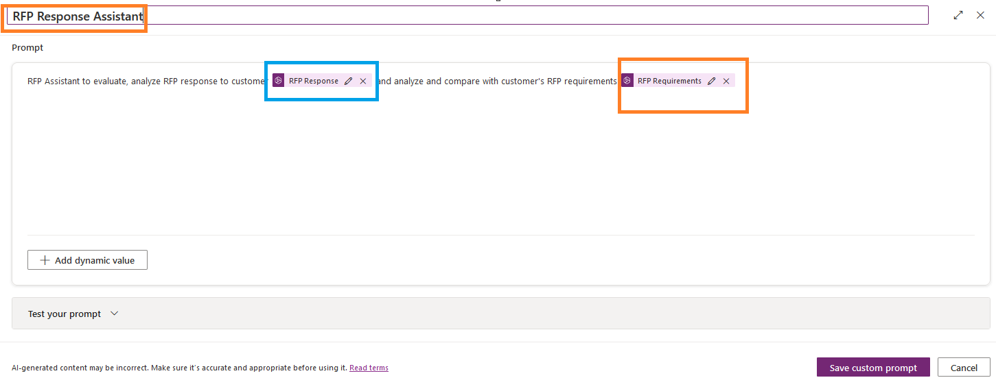

* Save the prompt and click on the Test custom prompt button.
* You will need to provide input samples to test your scenario.
* Detailed and specific inputs will yield better results through AI prompt.

Only a sample text input applied here. We can utilize automation functions for document input as well.

Click on test prompt and AI prompt model will start the action and provide you with the results.

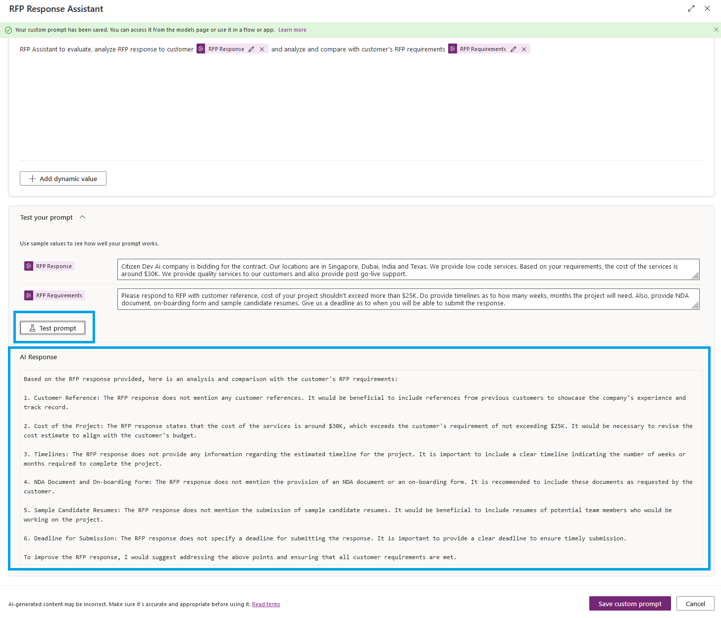

* The results are available for you to review, approve and take the next best actions.
* You can share the prompt with other users for reference. However, prompt in an app will be more meaningful and productive for end users.

**Using AI Prompt as GPT generated text output in Power Apps for users to consume.**

* We shall then utilize this prompt in the Power Apps concepts so we can share the prompt in app form for users to use as part of their job.
* Head over to make.powerapps.com and create a screen with 3 text input boxes.
  + 1 for RFP requirements
  + 1 for RFP response
  + 1 for AI to process the results as output to users.

Data source should point to the custom prompt that you created. In this case it is called RFP Response Assist

On click of AI button, call the prompt as a variable which reads both requirements and response and insert the output in the AI recommendation text box.

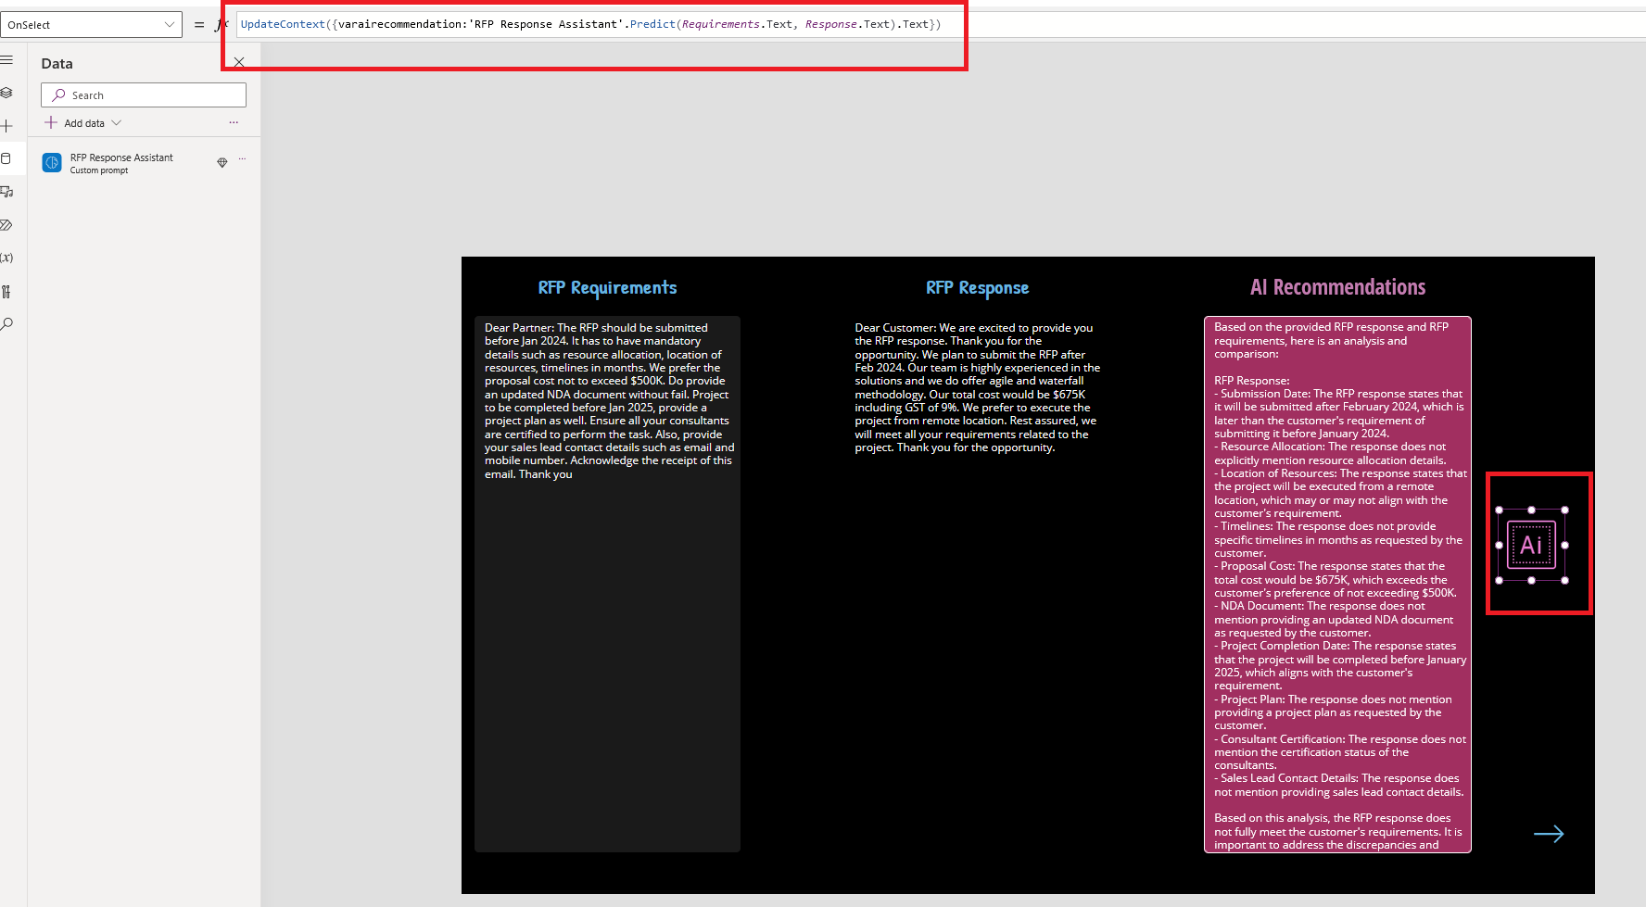

**Sample Prompt:**

**Responsible AI App:** Make sure there is a layer of approval against the data generated before it is used or sent to other parties or internal to your team. In this case, we can add a Power Automate Flow and send the approvals to TEAMS and have an added email button which sends the AI generated output via outlook or any email/SMTP/POP3 provider.

Email Output of the AI response:

Teams’ approval over the AI response generated:

**Comments**:

AI prompt is a great addition to the AI Hub within Power Platform for business users to utilize. Though this sample only covers ‘text’ as input and output, utilize pro-dev method along with Azure AI Doc automation capabilities for file ‘attachments’ which uses the same concept.